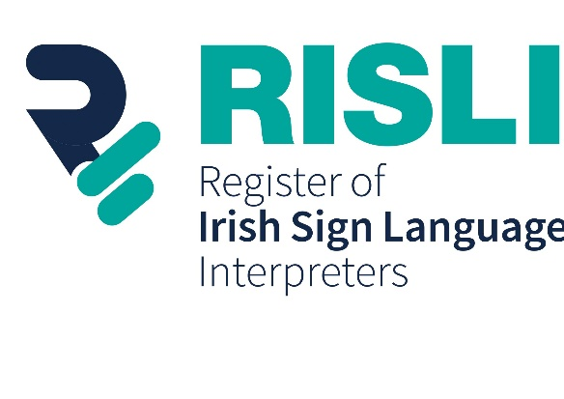
Link to the Advertisement in Irish Sign Language
RISLI is seeking expressions of interest from appropriate individuals, to join the Registration Panel of the Register of Irish Sign Language Interpreters (RISLI).

Background
The National Disability Inclusion Strategy (NDIS) and the Irish Sign Language Act (2017) tasked the Sign Language Interpreting Service (SLIS) with establishing a Registration and Quality Assurance Scheme for Irish Sign language (ISL) Interpreters. SLIS is an independent company, funded and supported by the Citizens Information Board (CIB) which lies under the aegis of the Department of Social Protection, that works to enhance the availability and quality of ISL interpreting in Ireland in response to the National Disability Inclusion Strategy (NDIS) 2017-2021 and the Irish Sign Language Act 2017.
The Regulatory Centre for Irish Sign Language Interpreters Ireland CLG has been established for the purpose of maintaining the register and quality assurance scheme of ISL Interpreters
(“the Register”). The Register is a standards-based registration system for ISL Interpreters, which includes specific criteria for registration, quality assurance and Continuous Professional Development and training. This company operates under the business name of RISLI. The Registration Panel assumes the role of decision maker in relation to all relevant matters connected with the Register. SLIS provides administrative support to RISLI.

Registration Panel Members
RISLI is seeking expressions of interest from individuals, who have the appropriate skills, experience and capacity, in governance, the Deaf community, interpreting, finance, training, compliance in community and voluntary organisations/charities, legal and strategy development.

The Panel consists of 7 members who serve on a voluntary basis. The Registration Panel is seeking an additional three members. It is intended the additional members will include:

- One member with experience in the establishment and/or operation of an established Register
- One Deaf expert in interpreting and the Deaf Community
- One member with expertise in law/governance

Panel Duties:

- The Panel will develop and operate a national registration and quality assurance scheme for ISL Interpreters in Ireland.
- Meetings will take place as necessary. Panel meetings are currently held monthly.
- As a voluntary Panel no fees will be paid to Panel members, however, travel and subsistence expenses will be paid when applicable.
- Appointments are initially for a term of three years, which can be renewed.

If you believe you have the appropriate experience and skills, this is a great opportunity to contribute to the development of a new professional registration and quality assurance scheme for ISL interpreters, including Deaf interpreters.

Application Process
Application Forms should be forwarded by email to RISLI at admin@risli.ie as an initial first step in the application process.

A Selection Committee will consider and assess the expressions of interest received and will be based on a review of applicant’s documentation received.

You can download the following from www.risli.ie and the Activelink website.
- Application Form
- Expression of Interest Ad
- Registration Panel – Structure and Governance
- Registration Panel – Code of Conduct
- Registration Panel – Membership & Operation

Closing date for receipt of applications is 2pm Wednesday 5th May 2021

For details on how your personal data will be used as part of this process our Data Protection Notice for job applicants is available at:

http://www.citizensinformationboard.ie/en/data_protection/slis.html

